**TI BYTE Simulation Exercise**

**Week 5 : Buffers**

* **Question 1:**

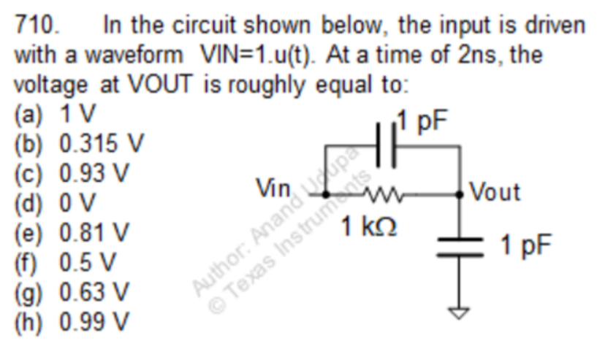

* **QUCS Circuit:**

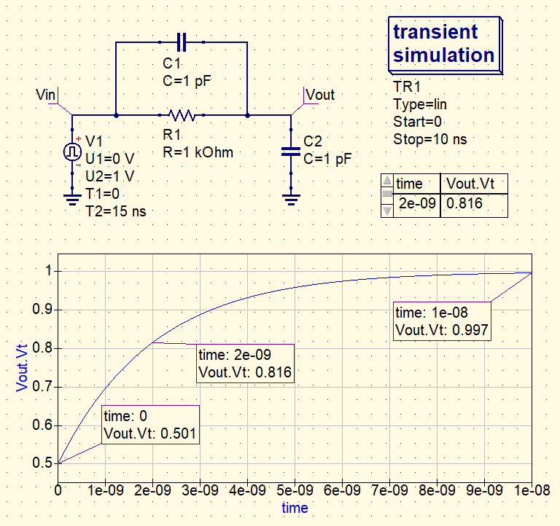

* **Vin is the input given with waveform Vin = 1.u(t)**
* **Vout is used to label the output node and find the voltage at that node.**
* **Both the capacitors are uncharged and have zero initial voltage in them.**
* **QUCS Result:**

**Therefore, from the simulation, we get our answer as:**

**Vout | at t = 2 ns = 0.816 V ≈ 0.81 V**

**Answer: (e)**

* **Conclusion:**
* **Initially, since the capacitors are uncharged, they provide minimal impedances. So, at t = 0+,**
* **At t = ∞, the capacitors are charged and behave as o.c., therefore,**
$$V_{out}=V_{in}=1 V$$

* **The $R_{eq}$ of the circuit between $V_{out}$ and $V_{in}$ is = 1 kΩ**
* **The $C_{eq}$ of the circuit between $V_{out}$ and $V_{in}$ is = 1 pF + 1 pF = 2 pF**
* **Time constant of the circuit = $R_{eq}× C_{eq}=1 kΩ ×2 pF=2 ns$**
* **Therefore, using the F.I.F. formula, we get the charging curve of $V_{out}$ across the capacitor C2,**

$$V_{out}=V_{f}+(V_{i}-V_{f})e^{{-t}/τ}$$

**where, $V_{i}$ = $V_{out}(t=0^{+})$ and $V_{f}$ = $V_{out}(t=∞)$.**

$$V_{out}=1+(0.5-1)e^{{-t}/{2 ns}}$$

* **Thus, at t = 2 ns, $V_{out}=1-0.5×e^{{-2 ns}/{2 ns}}=1-0.5×e^{-1}$**

**= 0.816 V**

* **Thus, our answer is verified with the simulated result.**
* **Question 2:**

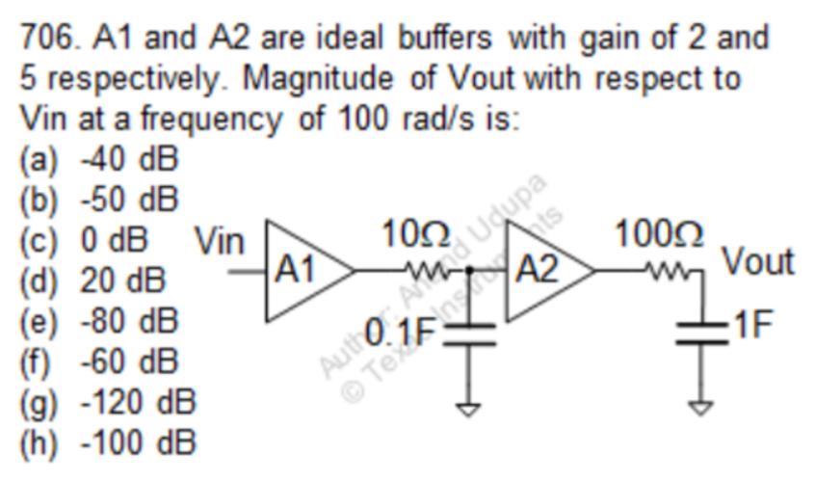

* + **QUCS Circuit:**

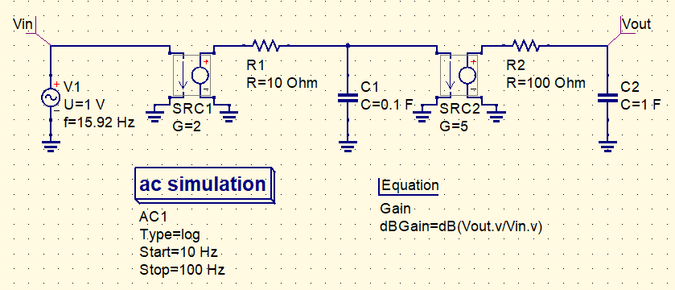

* **Vin is a sinusoidal input given with an amplitude of 1V and frequency of 100 rad/s = 15.915 Hz**
* **Vout is used to label the output node and find the voltage at that node.**
* **Both the capacitors are uncharged and have zero initial voltage in them.**
* **The Buffer Amplifiers are implemented using Voltage Controlled Voltage Sources (VCVS), since they are ideal buffers with infinite input resistance and zero output resistance.**
* **QUCS Result:**

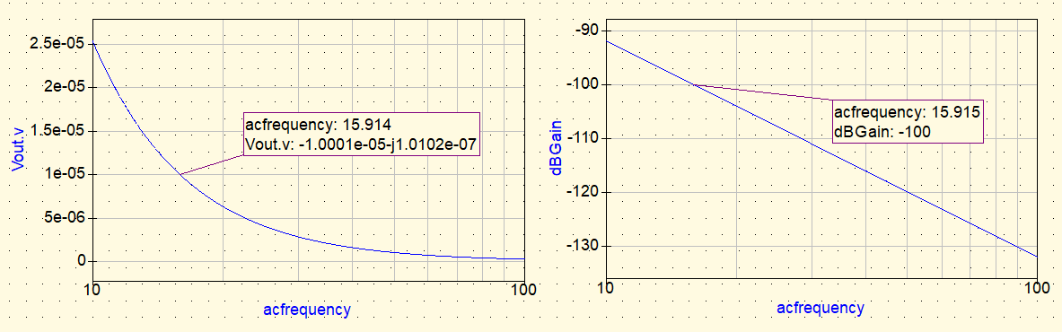

**Therefore, from the simulation, we get our answer as:**

**Av = -1.0001e-05 – j1.0102e-07 = -100 dB**

**Answer: (h)**

* **Conclusion:**
* **The Transfer function can be given by.**
$$H\left(s\right)= \frac{V_{out}}{V_{in}}=\frac{A_{1}A_{2}}{(1+sR_{1}C_{1})(1+sR_{2}C_{2})}$$

* **Thus H(s) has two poles and no zeroes.**
* **The total DC gain between $V_{in}$ and $V_{out}$ $(A_{V_{0}})$ = A1 × A2**

**= 2 × 5 = 10**

$A_{V_{0}}$**= 20 dB**

* **Now, due to the presence of the buffers, the two RC circuits R1C1 and R2C2 are electrically isolated. Thus, the effect due to the poles are also independent of each other.**
* **Therefore, the pole due to R1C1 is,**

$$ω_{1}= -\frac{1}{10 Ω ×0.1 F}= -1 rad/s$$

**and, the pole due to R2C2 is,**

$$ω_{2}= -\frac{1}{100 Ω ×1 F}= -0.01 rad/s$$

* **Since both the pole lie on the -ve s-axis of the s-jω plane, the system is stable.**
* **For a single pole at any frequency, the roll-off rate is -20dB/ decade.**
* **Now, at $ω=100 rad/s$, Gain due to the individual poles,**
$$A_{V_{1}}=-20×log \left(\frac{ω}{|ω_{1}|}\right)=-20×log \left(\frac{100}{1}\right)=-40 dB$$

$$A_{V_{2}}=-20×log \left(\frac{ω}{{|ω}_{2}|}\right)=-20×log \left(\frac{100}{0.01}\right)=-80 dB$$

* **Thus, total gain at $ω=100 rad/s$,**
$$A_{V}= A_{V_{0}}+ A_{V_{1}}+ A_{V_{2}}=20 dB-40 dB-80 dB= -100 dB$$

* **From the simulation, we got the same result, thus our answer is correct and verified.**